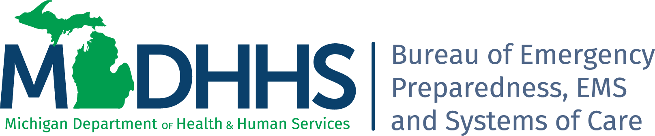

2023 Partnership Face to Face Meeting
May 8-Joint Session & May 9-LHD and Tribal

Meeting Information

Location: Amway Grand Plaza Hotel

187 Monroe Ave. NW
Grand Rapids, MI 49503

Microsoft Teams meeting 10:00 AM to 3:00 PM Only
Join on your computer, mobile app, or room device
Click here to join the meeting
Meeting ID: 245 889 465 572
Passcode: DLR5eQ
Download Teams | Join on the web

Monday May 8th
9:00-10:00am: Check In-Imperial Room Entry 1st Floor Pantlind Lobby

10:00-10:10am: Welcoming Remarks
Jay Fiedler, Division Director, Division of Emergency Preparedness and Response, Bureau of Emergency Preparedness, EMS, and Systems of Care (BEPESoC)

10:10-11:00am: Collaboration Opportunities
Matthew Price, Regional Coordinator Region 1, Jodi DeFrenn, EPC Shiawassee County Health Department, Susie Dice, EPC Lenawee County Health Department

11:00-11:15am: Additional Focus on Access and Functional Needs as it relates to WCI
Dr. Kerry Chamberlain, Outreach, Evaluation and Exercise Liaison

11:15-11:45am: 2023-2026 National Health Security Strategy
Dr. Karla Black, Deputy Administrative Health Officer, Kent County Health Department

11:45-12:15pm: Box Lunch – Networking

12:15-1:00pm: Med Surge Updates
SPRN/RESPTC Project Update – Jessica Gould, Healthcare Preparedness Specialist
LHD Role in Fatality Management – Jessica Gould, Healthcare Preparedness Specialist and Jeannie Byrne, MCM Specialist

1:00-1:45pm: Tribal Partners Panel Discussion
Breanna Knudsen, Saginaw Chippewa, Stella Chippewa, Grand Traverse Bay Band, Joy Parish, Stephanie Phipps, Bay Mills Indian Community, Jolanda Murphy, Stella Chippewa and Mari Raphael, Grand Traverse Band, Mallory Horwath, Match-E-Be-Nash-She-Wish, Gun Lake Tribe, Brandy McCoy, Sault Ste Marie Tribe of Chippewa Indians

1:45-1:55pm: Break – Snack

2:00-2:30pm: End of the Day Wrap Up
Planning Committee Members

2:30-3:00pm: ASPR Update & Closing Remarks
CPT Duane Wagner, ASPR Project Officer, Tony Voirin, Regional Emergency Coordinator Region 5, Linda Scott, Bureau Director, Bureau of Emergency Preparedness, EMS, and Systems of Care (BEPESoC)

Healthcare Coalition Meeting 3:15-5:00pm: Vandenberg Room (Second Floor-Pantlind NE Corner)

Local Health and Tribal Meeting Continues Pantlind Ballroom 3:15-5:00pm
3:15-4:00pm: Overview of Homeland Security Exercise and Evaluation Program (HSEEP)
Larry Zimmerman, Exercise and Training Coordinator, Dayna Kapp, Delta-Menominee DHD, Emilie Stack, Marquette County HD and Tim Mautz, Wayne County Department of Health, Veterans and Community Wellness

4:00-5:00pm: LHD COOP Planning and Implementation Tools
Jason Smith, MDHHS Emergency Management Coordinator

Tuesday May 9th
Microsoft Teams meeting
Join on your computer, mobile app or room device
Click here to join the meeting
Meeting ID: 259 853 064 594
Passcode: CKsxwY
Download Teams | Join on the web
Or call in (audio only)
+1 248-509-0316,,860276085# United States, Pontiac
Phone Conference ID: 860 276 085#
Find a local number | Reset PIN
Learn More | Meeting options

7:30am: Continental Breakfast - Imperial Room Entry 1st Floor Pantlind Lobby

8:00-9:30am: Public Health 3.0 Presentation
Jennifer Sorek, Ottawa County HD, Jasmine Akuffo, NACCHO, Hassanatu Blake, NACCHO and Glenda Young-Marquez, NACCHO

9:30-10:00am: Look back activity, things learned during COVID
Jennifer Zordan, VanBuren Cass DHD, Sheila Moore, Mid-Michigan DHD, Don Derryberry, Tuscola County Health Department

10:00-11:00am: EPCs, Tribes, and Regional Points of Contact
Conversation Lead by: Jennifer Zordan, VanBuren Cass DHD

