SAVE THE DATE
Continuing Advances in Special Pathogen Response
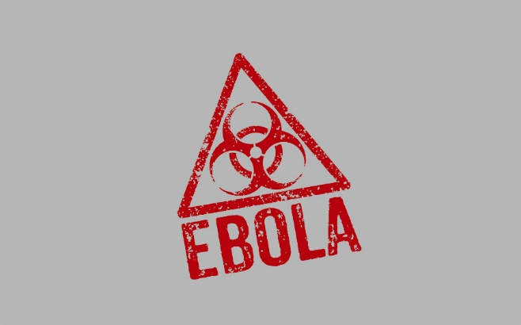

September 9th, 2019

Kellogg Hotel & Conference Center
219 S Harrison Road, East Lansing, MI 48824-1022
Who should attend: Hospital Staff, Physician Assistants, Nurses, Allied Health Professionals, EMS, Regional Healthcare Coalition Members, Local & State Public Health, Tribal Health, Health Profession Students, Emergency Management and Behavioral Health
Applications for continuing education credits have been submitted.

Additional information and registration materials will be available soon at http:/www.train.org/mitrain. Course ID: 1084417

A limited room block has been reserved and is being offered at the
State rate of $85.00 for a single room.

For reservations: www.kelloggcenter.com Group Code: 1909CONFER
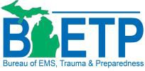

This conference is supported 100% by the Michigan Department of Health and Human Services with funding from the U. S. Department of Health and Human Services (HHS) Centers for Disease Control and Prevention, Public Health Emergency Preparedness Cooperative Agreement Award U90TP000528-03S2.
The views expressed in written conference materials or publications and by speakers and moderators do not necessarily reflect the official policies of the Department of Health and Human Services, nor does the mention of trade names, commercial practices, or organizations imply endorsement by the U.S. Government.

