Save-the-Date
State, Local and Tribal Health Emergency Preparedness
Partnership Meeting
May 6-7, 2019

Meeting Registration: MI-TRAIN, Course ID 1083455
Registration deadline: April 5, 2019

Meeting Location: Kent County Health Department
700 Fuller Ave NE, Grand Rapids, MI 49503

Monday, May 6
Registration: 8:00AM
Meeting: 8:30AM – 4:30PM
Continental breakfast and lunch provided

Tuesday, May 7
Meeting: 8:00AM – 11:3OAM
Continental breakfast and boxed lunch provided
Great Lakes Homeland Security Conference Opening Session: 1:00PM

Available Amway Grand Plaza
Lodging 187 Monroe Ave NW, Grand Rapids, MI 49503

Room rate: $126 per night plus applicable taxes (May 5-6 only. Self-pay)
Parking: $29 per day
Reservations: https://book.passkey.com/e/49874105

Important information about lodging:
- For convenience only, a room block has been secured at the Amway Grand Plaza for the nights of Sunday, May 5 and Monday May 6.
- Lodging reservations and costs are the responsibility of the individual attendee and are an allowable use of PHEP funds.
- The room block will remain open through April 5, 2019, after which the rooms will be released and there will be no guarantee of availability or pricing

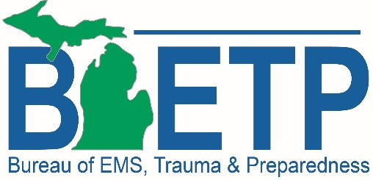
For questions regarding the Partnership Meeting, contact Tracey Belknap at BelknapT1@michigan.gov.

