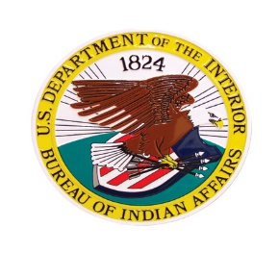 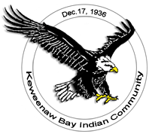

**INCIDENT COMMAND TRAINING**

**\*\*ICS-300\*\***

**FEBRUARY 24-26TH, 2023 -ICS 300**

**2/24/2023 1730-2200**

**2/25/2023 0800-1700**

**2/26/2023 0800-1600**

**This Course is sponsored by the Michigan Agency- Bureau of Indian Affairs and the Keweenaw Bay Indian Community.**

**Location of Class: Baraga Lakeside Inn, 900 US Hwy. 41, Baraga, Mi.**

**Course limited to 24 students-**

**Course instructed by BIA/NWCG certified instructors. Questions please call- (906)-287-1151**

**Please submit email containing name, phone #, with ICS 100 and 200 certificates by 2/19/2023 to:** [**jackpineincidentmanagement@gmail.com**](mailto:jackpineincidentmanagement@gmail.com)