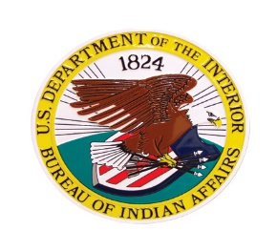 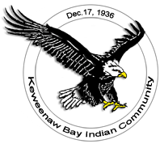

**INCIDENT COMMAND TRAINING**

**\*\*ICS-400\*\***

**MARCH 17T-18TH, 2023 -ICS 400**

**3/17/2023 1730-2200**

**3/18/2023 0800-1730**

**This Course is sponsored by the Michigan Agency-Bureau of Indian Affairs and the Keweenaw Bay Indian Community.**

**Location of Class: Baraga Lakeside Inn, 900 US Hwy. 41, Baraga, Mi.**

**Course limited to 24 students-**

**Course instructed by BIA/NWCG certified instructors. Questions please call- (906)-287-1151**

**Please submit email containing name, phone #, with ICS 100/200/700 and 800 certificates by 3/5/23 to:** [**jackpineincidentmanagement@gmail.com**](mailto:jackpineincidentmanagement@gmail.com)