Date:

Ordered by Name:

Organization:

Describe Intended Audience:

Indicate Distribution Method: Handed Directly to People___ Left in Public Place___ Mailed ___

Ship to Address:

Phone number:

*CTRL+Click on the title to open a PDF on the Stay Well website to view the brochure.*

# [For Older Adults Recovering from the Emotional Toll of COVID-19](https://www.michigan.gov/documents/coronavirus/For_Older_Adults_Recovering_From_the_Emotional_Toll_of_COVID-19_697255_7.pdf)

**Quantity**

|  |  |
| --- | --- |
| English |  |
| Arabic |  |
| German |  |
| Simplified Chinese |  |
| Spanish |  |

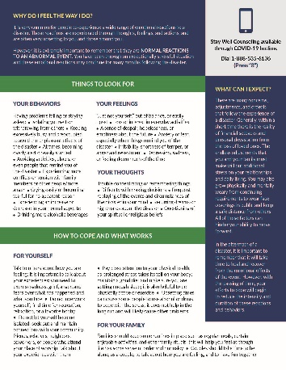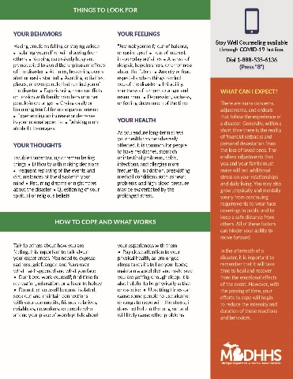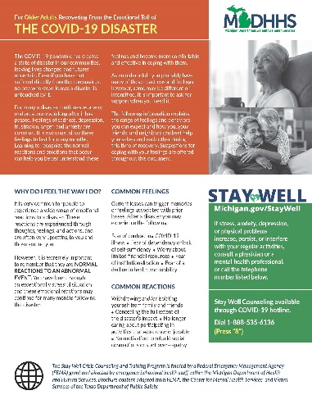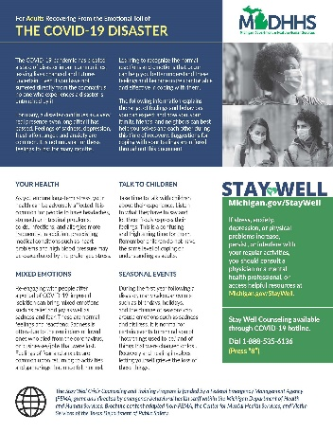

# [For Adults Recovering from the Emotional Toll of COVID-19](https://www.michigan.gov/documents/coronavirus/For_Adults_Recovering_From_the_Emotional_Toll_of_COVID-19_697256_7.pdf)

**Quantity**

|  |  |
| --- | --- |
| English |  |
| Arabic |  |
| German |  |
| Simplified Chinese |  |
| Spanish |  |

# [Helping a Child Recover from the Emotional Toll of COVID-19](https://www.michigan.gov/documents/coronavirus/Helping_a_Child_Recover_From_the_Emotional_Toll_of_COVID-19_697254_7.pdf)

|  |  |
| --- | --- |
| English |  |
| Arabic |  |
| German |  |
| Simplified Chinese |  |
| Spanish |  |

**Quantity**

**Front**

**Inside**

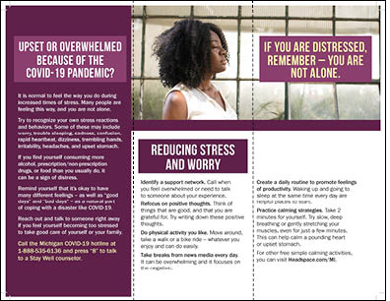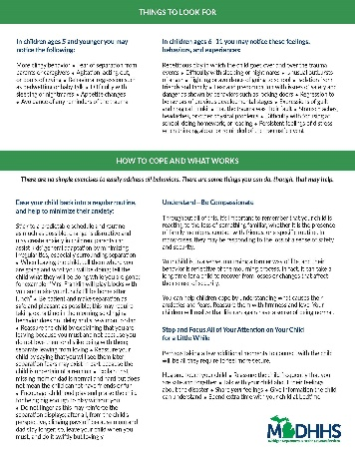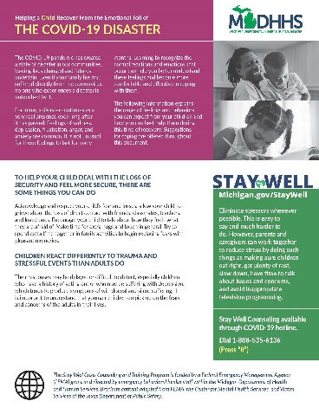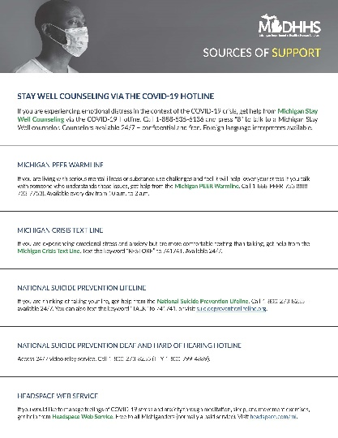

# Sources of Support

|  |  |
| --- | --- |
| English |  |
| Arabic |  |
| German |  |
| Simplified Chinese |  |
| Spanish |  |

**Quantity**

# Tri-Fold Pamphlet: SUPPORT, CONNECT, COPE

|  |  |
| --- | --- |
| English |  |

**Quantity**

**[Tips for Helping Children Cope with Stress](https://www.michigan.gov/documents/coronavirus/Tip_Sheet_for_Helping_Children_Cope_with_Stress_697253_7.pdf)

|  |  |
| --- | --- |
| English |  |
| Arabic |  |
| German |  |
| Simplified Chinese |  |
| Spanish |  |

**Quantity**